**CI/CD on Azure Databricks using Azure DevOps**

Continuous integration and continuous delivery (CI/CD) refers to the process of developing and delivering software in short, frequent cycles through the use of automation pipelines.

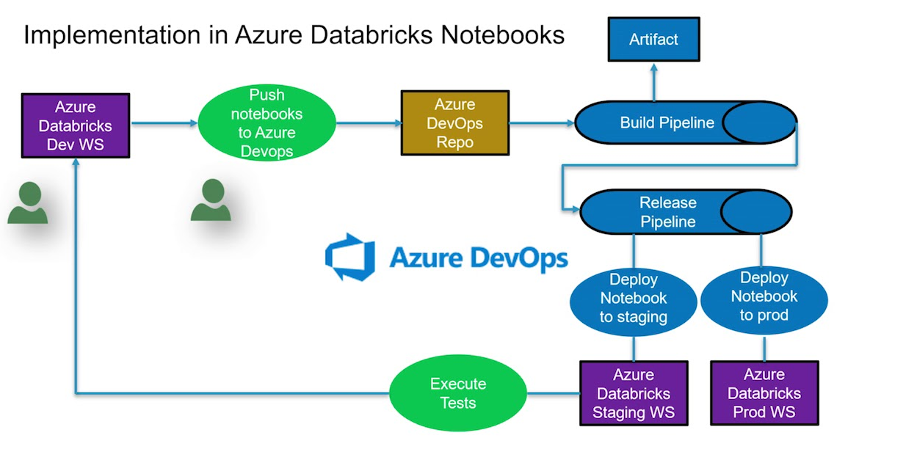

**Continuous integration:**

1. Code
   1. Develop code and unit tests in an Azure Databricks notebook or using an external IDE.
   2. Manually run tests.
   3. Commit code and tests to a git branch.
2. Build
   1. Gather new and updated code and tests.
   2. Run automated tests.
   3. Build libraries and non-notebook Apache Spark code.
3. Release: Generate a release artifact.

**Continuous delivery:**

1. Deploy
   1. Deploy notebooks.
   2. Deploy libraries.
2. Test: Run automated tests and report results.
3. Operate: Programmatically schedule data engineering, analytics, and machine learning workflows.

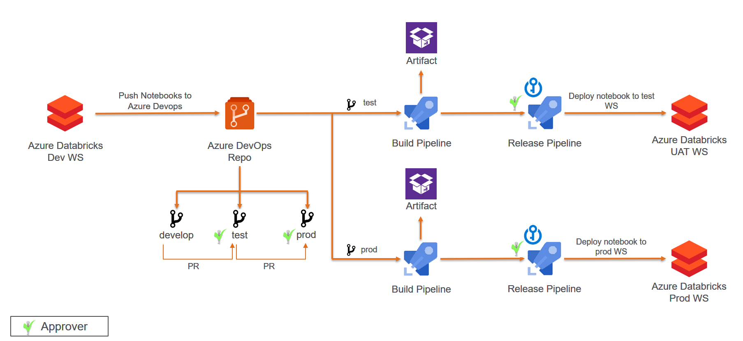

* Develop and commit your code in develop branch
* Push code from develop branch to → test branch → master branch
* Deploy Notebooks in different environments Dev →Test →Prod using CI/CD pipelines in Azure DevOps